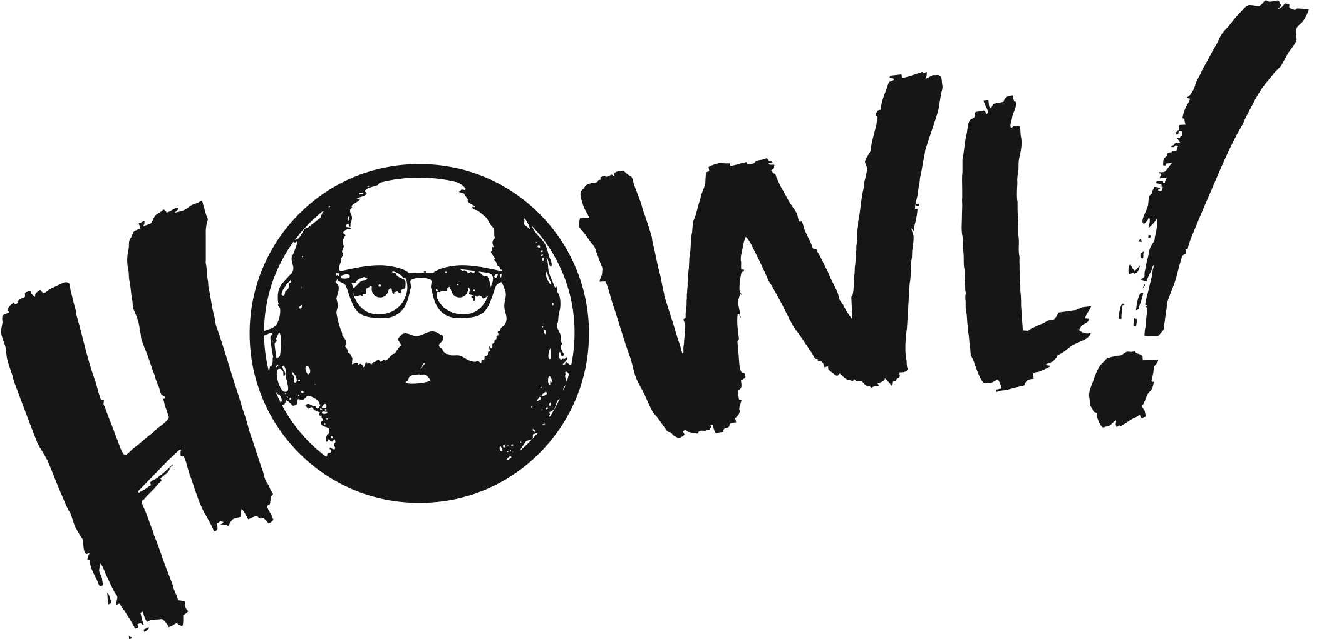

PRESS RELEASE
9/4/16

“It's All True”: The East Village Eye Show
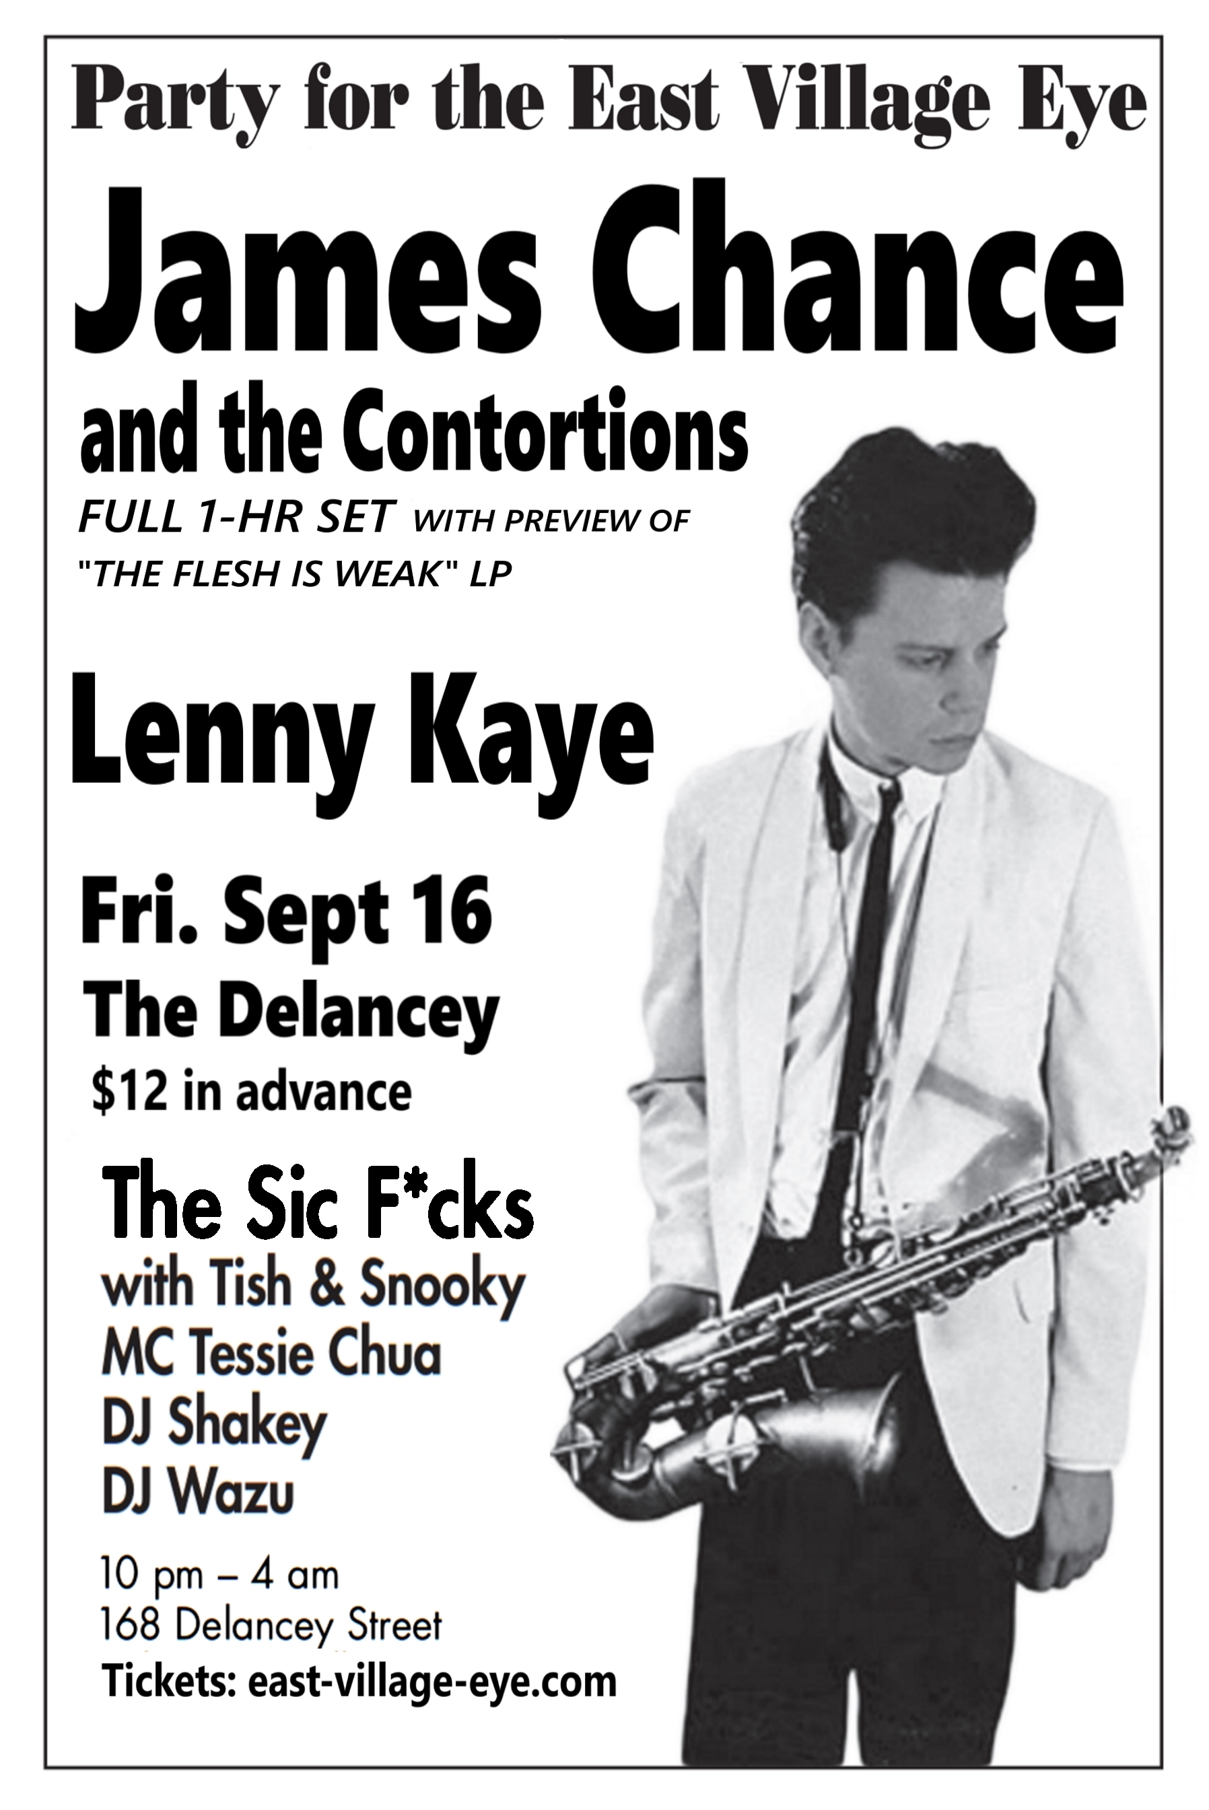
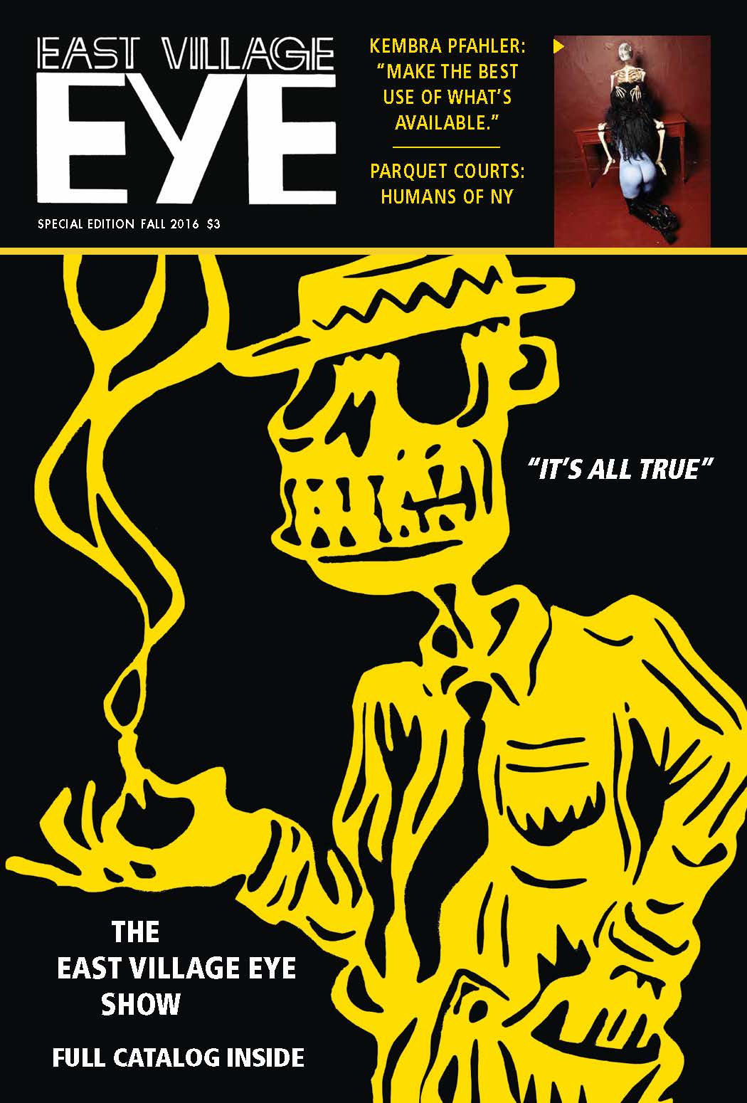
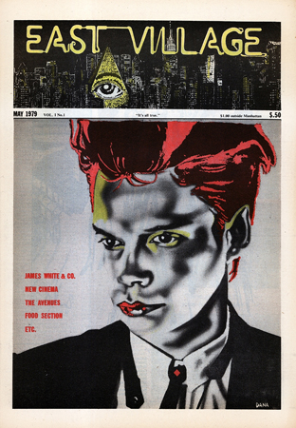

Friday, September 16–Sunday, October 9, 2016
Opening: Friday, September 16, 6-8 pm
Post-Opening Party Starring James Chance & The Contortions, Lenny Kaye and the Sic F*cks:
Friday, September 16, 10 pm at The Delancey

The Eye’s unswerving editorial position was to advocate for the neighborhood’s uniqueness, even when money became a central part of the equation.
—Dan Cameron in the catalog for the New Museum’s 2004 exhibition East Village, USA

Howl! Happening: An Arturo Vega Project is pleased to shine a light on another important source of East Village social and cultural history: The East Village Eye. A monthly magazine published from 1979 through 1987, The East Village Eye focused on popular and avant-garde culture, politics and other issues relevant to the East Village and environs. Self-styled as “a community in print,” the East Village Eye is noted for its groundbreaking coverage of the emerging punk, new wave and hip hop music scenes of the time, as well as the influential art, literature, film and performance worlds of the era.
The East Village Eye Show will feature covers, centerfolds, interior pages, ephemera and photographic prints, as well as key art works from artist that emerged during the era. The show draws from the nearly 4,000 pages, 3,000 photographs, sets of original copies and attendant materials that constitute The East Village Eye Archive, dubbed “the King Tut's tomb of downtown New York.”

The show of original artworks includes works by Sue Coe, Linus Coraggio, Duncan Hannah, Keith Haring, Rebecca Howland, Jody Morlock, James Nares, Judy Rifka, James Romberger, Kiki Smith, Marguerite Van Cook, Alan Vega and David Wojnarowicz.

Artist and Colab co-founder Christof Kohlhofer was the first art director of the Eye. Kohlhofer, who studied with Joseph Beuys, introduced Abrams to the influential artists who were a part of the flourishing EV art scene. “I credit Christof with steering the Eye towards art, but also for injecting a Beuys-like approach. Basically doing whatever was necessary at the time,” says Abrams, in the 2014 article in Hyperallergic, .The East Village Eye: Where Art, Hip Hop, and Punk Collided

As a result, the magazine featured art world luminaries including David Wojnarowicz, Richard Hell, Cookie Mueller, Lucy Lippard, and Rene Ricard. The magazine’s covers read like a who’s who of cultural influencers like Patti Astor, Robert Mapplethorpe, and Vito Acconci; emerging artists such as Sue Coe, Barbara Kruger and Kiki Smith; as well as musicians like Patti Smith, Run DMC, Annie Lennox, and the Beastie Boys.

Richard Hell explained how he and other New Yorkers, and not English kids, “invented" punk; Cookie Mueller dished out bold and often hilarious health advice; Glenn O’Brien, the leading avant-pop writer and media figure, expounded on the New York Yankees; and the aforementioned David Wojnarowicz wrote about his harrowing past and present as a street hustler and later as an artist living with HIV.

Creative collaboration was the hallmark of the magazine’s legacy. “The mix of fashion, music, art, politics, comics etc., the way it was presented by the Eye, the constant changing impact through all those different people who worked on the paper, and Leonard’s attitude not to interfere with that, made it a very lively subject,” says Kohlhofer in the Hyperallergic article.

Over a period of eight years, the magazine chronicled the spectacular rise and eventual implosion of the East Village art scene. The Eye's coverage of the arts and music scenes helped illuminate the psycho-social conflicts running through EV/LES culture, NYC, and beyond. Later issues of the Eye touched upon the beginnings of radical changes in the neighborhood. In April 1986 the magazine ran a feature on the rise of “The East Village Yuppie.” Sixth months earlier, the Eye’s art editor, Carlo McCormick, published an obituary for the neighborhood’s art scene. “Though the greed and envy have disbanded our beautiful community,” wrote McCormick, “the East Village will continue to exist as the simulacrum of itself. The art world is finally ready to preserve our youth like the glamorous visage of the internally decrepit Dorian Grey.”

East Village Eye – Special Edition
A special edition of the East Village Eye, just out this week, act as the catalog. The tabloid-sized magazine includes historical essays; political commentary; articles about current events and people who are impacting our world, and more. Look for stories on Kembra Pfahler, Andrew Savage of Parquet Courts, Steve Cannon and Edgar Oliver, just to name a few. The Catalog contains essays by Leonard Abrams, Anthony Haden-Guest and Walter Robinson, plus descriptions of the original artworks by Sylvia Falcon and the film program by Coleen Fitzgibbon, as well as a full-color centerfold featuring covers of the complete run of 72 issues.

Special Events are also planned. Check the Howl! Happening website for updates.

September 16: Opening 6-8, Party 10 pm starring James Chance & The Contortions, Lenny Kaye, the Sic F*cks with Tish & Snooky; host: comedian Tessie Chua; DJs: Shakey & Wazu
[Note: party is an outside event: The Delancey club is at 168 Delancey Street, NYC. Tickets: http://www.east-village-eye.com/tickets.html ]
September 18: Panel Discussion: “East Village Art: Scene or Circumstance?”
Moderated by Leonard Abrams, with Yasmin Ramirez, Sur Rodney (Sur),
Arthur Fournier and Anthony Haden-Guest
September 24: New/No Wave Films:
3:00 LES (Lower East Side) by Coleen Fitzgibbon
3:20 Liberty’s Booty by Vivienne Dick
4:15 You Are Not I by Sara Driver
Intermission
5:30 Rome '78 by James Nares
September 25: Cinema of Transgression films:
3:00 Unannounced Shorts
3:15 Thrust in Me by Richard Kern
3:30 Stray Dogs by Richard Kern
3:45 Simonland by Tommy Turner
4:00 Where Evil Dwells by Tommy Turner & David Wojnarowicz
Intermission
4:45 They Eat Scum by Nick Zedd
October 6: Channeling the Dead: Readings of stories by deceased writers Kathy Acker, Cookie Mueller, Rene Ricard, David Wojnarowicz, Jesse Bernstein and (too many) others. Hosted by Bob Holman; readings by Leonard Abrams, Max Blagg, Bob Holman, David Huberman, David Katz, Catherine Texier, Carl Watson and others to be announced.

Ultimately, The East Village Eye was the monthly record of a time and place in which the radical shifts of the post-Vietnam era produced a reckless thirst for experience and expression that redefined the world we live in today. Through this exhibition, Howl! Happening stands in solidarity with the EV/LES artists and community—past and present—whose creativity continues to fuel us.

Howl! Happening: An Arturo Vega Project
6 East First Street (between Bowery & 2nd Avenue)
New York, NY 10003
(917) 475-1294
contact@howlarts.org
Gallery Hours: Wed-Sun, 11–6 PM
ABOUT HOWL! HAPPENING

X X X X X
For further information contact: MartinMPR
Susan Martin, susan@martinmpr.com
Norma Kelly, norma@martinmpr.com

